HUM 2220, Greek/Roman Humanities
Study Questions on the Iliad

What to know about the Iliad

The Trojan War as related by the Greek poet, Homer, in his two epic poems the Iliad and the Odyssey is the one great defining moment of ancient Greek culture. The historical veracity and accuracy of the events as related in the two epic poems can never be proven. However, there is historical proof that a war did take place around the city of Troy that resulted in the city’s destruction. What is known for sure is that Homer’s narration so engaged and captured the imagination of the Greeks that the two epic poems became their cultural Bible. The cultural events, the characters, the rituals, the religion, the moral ethics, the family values as told in the poems became the measurement of ethics for the ancient Greeks.
The Greeks at the time of the Trojan War were not really the Greeks of the era of the Golden Age of Greece. The Greeks who fought the Trojan War were actually the Myceneaens of the Aegean culture. They probably included Dorians and Ionians as well. But the Trojan War represented for the later Greeks, the first time in known history when the city-polis came together as one with a common purpose. This unification gave the later Greeks, who were listening to the recitation of the Iliad, a sense of national and cultural identity. This sense of unification represented superiority in having a common language, common values and customs, and a common religion.
Therefore, the poetry of Homer, became increasingly important to the Greeks because the texts related the values and ethics of their common identity. The texts are literary texts, however, not religious texts or ethical texts. The Greeks understood that Homer took literary license in his unflattering portrayal of the Greek gods, for example.
Even after the Greeks abandoned their cities and their ability to write, the history of the Trojan War was preserved by an oral tradition. The bards or story-tellers were probably the cultural center of that Greek society. The professional story teller would sing or recite the stories of the Trojan War and its Greek heroes.
As the Greeks began to urbanize, writing was rediscovered, probably learned from the Phoenicians. The Homeric poems were committed to writing very quickly with the onset of literacy.

Abstracted from Bureaucrats & Barbarians, The Greek Dark Ages,
http://www.wsu.edu:8080/dee/MINOA/HOMER, 1/11/99
Essay study questions for Books 1-5

1. What are the moral values that define Greek character? Which characters best display these moral values in their deportment on and off the battlefield?

2. What is the role of women? Are there any strong-female characters? How is Helen presented?

3. What is the “heroic code” that guides the decisions of characters? Which character or characters emerge as more heroic than others and why?

4. What is the role of the gods? What is their relationship with the mortals? (Be specific.)

S What is the importance of rituals? Cite examples.

6. What is the role of Fate? Who is the most victimized by Fate?

What to know:

1. the kings and their city-polis
2. the reason for the anger of Achilles
3. the Judgment of Paris
4. the list of gods and goddesses

Vocabulary:

1. hecatomb
2. greaves
3. ichor
4. libation

Who says what and to whom. Identify the following. Tell who says it and identify the situation.

1. “You wine sack”
2. “This is a disastrous matter when you put me in conflict with Hera...”
3. ...of the shining helm
4. strong son of Anchises
5. “...like a lion who comes on a mighty carcass”
6. “...beautiful, woman-crazy, cajoling, better had you never been born...”
7. “Never to be cast away are the gifts of the gods...”
8. “Come over where I am, dear child, and sit down beside me, to look at your husband of time past, your friends, and your people.”
9. “...now I am worn with weeping”
10. “...they were sitting close to each other, devising evil for the Trojans.”
11. “...he went storming up the plain like a winter-swollen river in spate that scatters the dikes in its running current.”
12. “…I have shot my shaft already, and hit him in the shóulder...yet I have not beaten him...”
13. “Keep yourself, Aineias, the reins and your horses.”
14. “Father Zeus, are you not angry looking on these acts of violence?... It is your fault we fight, since you brought forth this maniac daughter.”
15. “To me, you are the most hateful of all gods who hold Olympos”

Who are the following:

1. Chryses
2. “the best of the bird interpreters”
3. “the greediest for gain of all men”
4. Peleus’ son
5. Atreides
6. “lucid speaker of Pylos”
7. “beloved companion of Achilles”
8. mother of Achilles
9. Danaans
10. “the renowned smith”
11. “ox-eyed lady”
12. “greatest among them all, and led the most people”
13. Alexandros
14. Aphrodite’s favorite
15. “resourceful”
16. “wing-footed messenger”
17. son of Aphrodite
18. Tydeus’ son
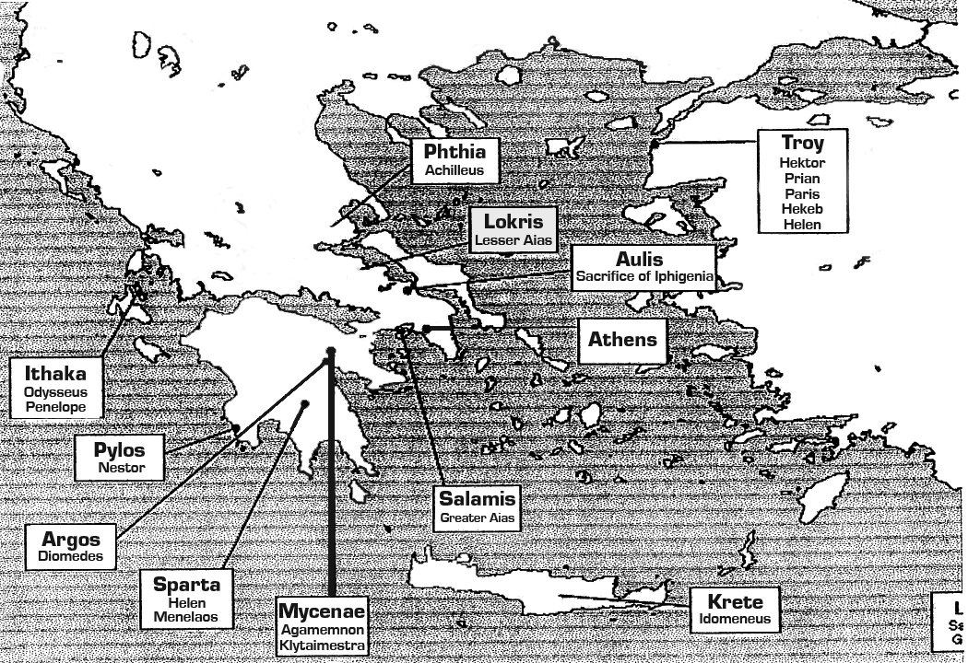

Map developed by Daphne Kleps.

To look up other sites mentioned in the Iliad, you can try searching the atlas provided by the Perseus Project at Tufts University.

There is also an excellent Glossary in the back of the Lattimore translation of the Iliad which includes place names.

2. Basic Chronology of the Homeric Epics (all dates BC)

BRONZE AGE (3000-1100)

c. 1800-1250 Troy VI
c. 1500-1120 Mycenaean Civilization
c. 1250 possible date of the historical fall of Troy VI
1183 traditional date of the fall of Troy

DARK AGES (1100-800)

c. 1100-750 Stories of the fall of Troy passed down in oral form
c. 1100 Doric Invasion of Greece
1050-950 Greek colonization of Asia Minor (western coast of Turkey)
900 Beginning of the rise of the polis (city-state)

http://academic.reed.edu/humanities/110Tecb/Iliad.html

